The District of Gelligaer

THE SACRED THREE DAYS

*Over the next three days we will follow the drama of our redemption played out in one act of worship comprising three celebrations.*



**GOOD FRIDAY**

***Today we see Jesus arrested, tried and condemned, put to death by crucifixion and buried in a strangers tomb. With the disciples we wait for……..***

**..*Jesus is arrested, tried and put to death.***

**GOOD FRIDAY**

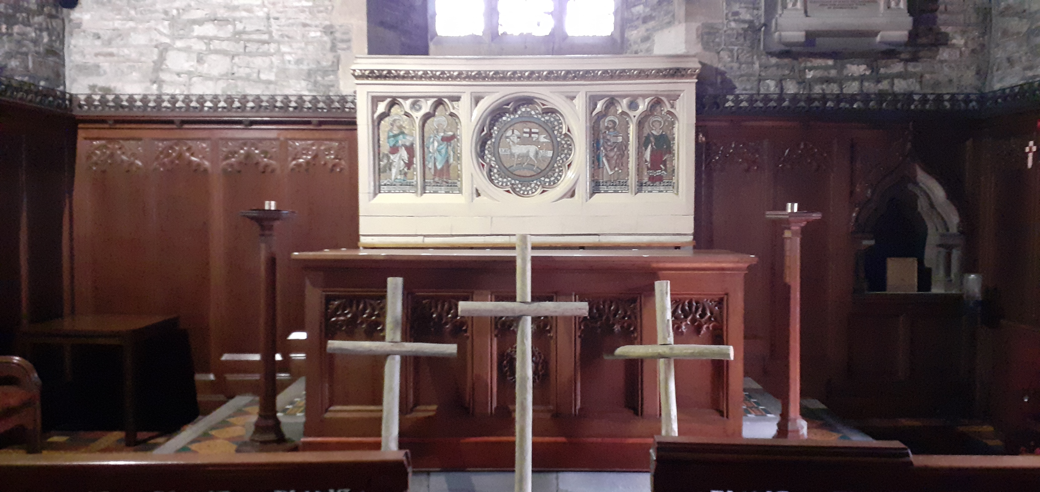

*Today we celebrate the passion and death of our Lord Jesus Christ: we listen to the words of scripture and strive to understand the true meaning of his suffering and death and we pray with the spirit for the needs of the whole world.*

Let us pray:

Almighty Father, look with mercy on this your family for which our Lord Jesus Christ was content to be betrayed and given up into the hands of sinners and to suffer death upon the cross; who is alive and reigns with you and the Holy Spirit, one God, now and for ever. Amen.

**A reading from the letter to the Hebrews:**  **(4: 14-16, 5: 7-9)**

Since we have a great high priest who has passed through the heavens, Jesus the Son of God, let us hold fast to the religion we profess. For ours is not a high priest unable to sympathise with our weaknesses, but one who because of his likeness to us, has been tested in every way, only without sin. Let us therefore boldly approach the throne of our gracious God, where we may receive mercy and in his grace find timely help. In the days of his earthly life Jesus offered up prayers and petitions, with loud cries and tears, to God who was able to deliver him from the grave. Because of his humble submission his prayer was heard: son though he was, he learned obedience in the school of suffering, and once perfected, became the source of eternal salvation for all who obey him.

This is the word of the Lord.  **Thanks be to God.**

**Psalm**:  **22 (1-11)**

**Response:** **My God, my God, why have you forsaken me?**

My God, my God, why have you forsaken me,

and are so far from my salvation, from the words of my distress?

O my God, I cry in the daytime, but you do not answer

and by night also, but I find no rest. **(R)**

Yet you are the Holy one, enthroned upon the praises of evil.

Our forebears trusted in you; they trusted, and you delivered them.

They cried out to you and were delivered;

They put their trust in you and were not confounded. **(R)**

*The Passion Gospel is read without responses.*

**THE PASSION OF OUR LORD JESUS CHRIST ACCORDING TO SAINT JOHN**

Pilate took Jesus and had him flogged. And the soldiers wove a crown of thorns and put it on his head, and they dressed him in a purple robe. They kept coming up to him, saying, ‘Hail, King of the Jews!’ and striking him on the face. Pilate went out again and said to them, ‘Look, I am bringing him out to you to let you know that I find no case against him.’ So Jesus came out, wearing the crown of thorns and the purple robe. Pilate said to them, ‘Here is the man!’ When the chief priests and the police saw him, they shouted, ‘Crucify him! Crucify him!’ Pilate said to them, ‘Take him yourselves and crucify him; I find no case against him.’ The Jews answered him, ‘We have a law, and according to that law he ought to die because he has claimed to be the Son of God.’ Now when Pilate heard this, he was more afraid than ever. He entered his headquarters again and asked Jesus, ‘Where are you from?’ But Jesus gave him no answer. Pilate therefore said to him, ‘Do you refuse to speak to me? Do you not know that I have power to release you, and power to crucify you?’ Jesus answered him, ‘You would have no power over me unless it had been given you from above; therefore the one who handed me over to you is guilty of a greater sin.’ From then on Pilate tried to release him, but the Jews cried out, ‘If you release this man, you are no friend of the emperor. Everyone who claims to be a king sets himself against the emperor.’ When Pilate heard these words, he brought Jesus outside and sat on the judge’s bench at a place called The Stone Pavement, or in Hebrew Gabbatha. Now it was the day of Preparation for the Passover; and it was about noon. He said to the Jews, ‘Here is your King!’ They cried out, ‘Away with him! Away with him! Crucify him!’ Pilate asked them, ‘Shall I crucify your King?’ The chief priests answered, ‘We have no king but the emperor.’ Then he handed him over to them to be crucified. So they took Jesus; and carrying the cross by himself, he went out to what is called The Place of the Skull, which in Hebrew is called Golgotha. There they crucified him, and with him two others, one on either side, with Jesus between them. Pilate also had an inscription written and put on the cross. It read, ‘Jesus of Nazareth, the King of the Jews.’ Many of the Jews read this inscription, because the place where Jesus was crucified was near the city; and it was written in Hebrew, in Latin, and in Greek. Then the chief priests of the Jews said to Pilate, ‘Do not write, “The King of the Jews”, but, “This man said, I am King of the Jews.” ’ Pilate answered, ‘What I have written I have written.’ When the soldiers had crucified Jesus, they took his clothes and divided them into four parts, one for each soldier. They also took his tunic; now the tunic was seamless, woven in one piece from the top. So they said to one another, ‘Let us not tear it, but cast lots for it to see who will get it.’ This was to fulfil what the scripture says, ‘They divided my clothes among themselves, and for my clothing they cast lots.’ And that is what the soldiers did. Meanwhile, standing near the cross of Jesus were his mother, and his mother’s sister, Mary the wife of Clopas, and Mary Magdalene. When Jesus saw his mother and the disciple whom he loved standing beside her, he said to his mother, ‘Woman, here is your son.’ Then he said to the disciple, ‘Here is your mother.’ And from that hour the disciple took her into his own home. After this, when Jesus knew that all was now finished, he said (in order to fulfil the scripture), ‘I am thirsty.’ A jar full of sour wine was standing there. So they put a sponge full of the wine on a branch of hyssop and held it to his mouth. When Jesus had received the wine, he said, ‘It is finished.’ Then he bowed his head and gave up his spirit. Since it was the day of Preparation, the Jews did not want the bodies left on the cross during the Sabbath, especially because that Sabbath was a day of great solemnity. So they asked Pilate to have the legs of the crucified men broken and the bodies removed. Then the soldiers came and broke the legs of the first and of the other who had been crucified with him. But when they came to Jesus and saw that he was already dead, they did not break his legs. Instead, one of the soldiers pierced his side with a spear, and at once blood and water came out. (He who saw this has testified so that you also may believe. His testimony is true, and he knows that he tells the truth.) These things occurred so that the scripture might be fulfilled, ‘None of his bones shall be broken.’ And again another passage of scripture says, ‘They will look on the one whom they have pierced.’ After these things, Joseph of Arimathea, who was a disciple of Jesus, though a secret one because of his fear of the Jews, asked Pilate to let him take away the body of Jesus. Pilate gave him permission; so he came and removed his body. Nicodemus, who had at first come to Jesus by night, also came, bringing a mixture of myrrh and aloes, weighing about a hundred pounds. They took the body of Jesus and wrapped it with the spices in linen cloths, according to the burial custom of the Jews. Now there was a garden in the place where he was crucified, and in the garden there was a new tomb in which no one had ever been laid. And so, because it was the Jewish day of Preparation, and the tomb was nearby, they laid Jesus there.

**Meditation:**

**“Then crucify was all their breath,**

**And for his death they thirst and cry.”**

The hosannas and the rejoicing that greeted Jesus on his arrival in Jerusalem and now just a memory. How quickly things have changed! After sharing the Passover meal with his disciples Jesus now finds himself alone, abandoned by his friends and under arrest. He is passed back and forth between Pilate and Herod, neither wanting to take responsibility for him. The Pharisees and the scribes manipulated the crowd to shout for his death. Pilate under pressure to keep the peace gives in to the mob and delivers Jesus to be crucified. God’s song of love, sung by Jesus has been met with songs of betrayal and rejection, and so another verse of God’s song of love begins. Before the excruciating physical pain of being nailed to the Cross through his wrists and ankles Jesus suffers the pain of being whipped and the exhaustion of carrying his own cross to the place of execution. He suffers the humiliation of being stripped in public and ridiculed by the Roman soldiers and the crowds. It is impossible for us to comprehend his pain and his humiliation. Yet despite all that he endured he sang his song of love to the very end. He sang for those who murdered him and those who called for his death, praying, “Father forgive them, for they know not what they are doing” as the nails were driven home. He reached out to the penitent thief, forgiving him and reassuring him, “today you will be with me in paradise.” At the point of his deepest anguish and despair, as he felt that God the Father had abandoned him Jesus thought of others. He was determined to fulfil his mission to the end, the make God’s love known to the world. Jesus was not merely a man of love, he was the personification of love, the divine love of God the Father for his people. The death of Jesus is one of the verses of God love song for the world, a song not just for those who were present that day, but a song for all who have ever lived or who will live. It is a song of love for each of us. Today we stand before the Cross of Christ. As we contemplate the image of Jesus on the Cross we can hear Christ singing his song of love for us, for me and for you. He in singing for all who are suffering at this very difficult time, for all who are lonely and isolated from family and friends and for those giving of themselves to help treat and care for others. On the Cross Jesus is singing his song of love for all of us.

**Intercessions:**

We pray for the Church throughout the world, for the leaders of the Church among them Andrew our Archbishop and Mary our Bishop. We pray for the clergy and people of our diocese and for our own ministry area; that the Church may faithfully work with Christ to proclaim the saving love of God to the world.

Lord in your mercy, H**ear our prayer.**

Have mercy on a world in turmoil, often forgetful of Christ’s sacrifice of love. In his death his Kingship is revealed, may the power of the Cross guide the nations on earth.

Lord, in your mercy…..**Hear our Prayer**

We pray for the people of our nation, for all who live, work and worship in our parish. We pray for family, friends and neighbours. We give thanks for all giving freely of their time to help and serve the needs of the vulnerable. Help us to love others as Christ loves us.

Lord, in your mercy…...**Hear our Prayer**

As your Son opens his arms on the cross to embrace the world we pray for all who are in need, for the sick, for all who are lonely, isolated and separated from family and friends. We pray for all who are bereaved and those who are distressed. We hold before God those known to us in need at this time and all whose names are recorded in our parish intercession books. May they find healing in the sufferings of Christ.

Lord, in your mercy……**Hear our Prayer**

We pray for all who have died, for our own departed loved ones and for all the recently departed. May the rest in the peace and joy of heaven in the company of all the saints.

Lord, in your mercy…….**Hear our Prayer**

We bring all our prayers for ourselves, our families, friends and neighbours and all for whom we pray to our heavenly Father:

**Our Father,**

**who art in heaven,**

**hallowed be thy name,**

**thy kingdom come,**

**thy will be done,**

**on earth as it is in heaven.**

**Give us this day our daily bread.**

**And forgive us our trespasses**

**as we forgive those who trespass against us.**

**And lead us not into temptation,**

**but deliver us from evil.**

**For thine is the kingdom, the power and the glory**

**for ever and ever. Amen.**

Most merciful God, who by the death and resurrection of your Son Jesus Christ delivered and saved humankind Grant that by faith in him who suffered on the Cross, we may triumph in the power of his victory, through Jesus Christ, our Lord. Amen.

***Jesus is taken from the Cross and buried…..***



***……. and the disciples***

***waited….***

*The Word of the Lord and other prayers: Copyright Church in Wales publications.*

*The Church in Wales Word of the Lord 2011 copyright © Church in Wales publications 2011*